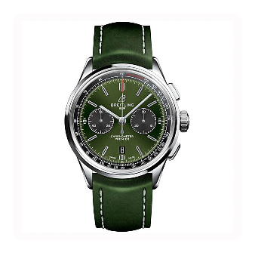

### ****Product Name:****

**Seiko Premier Kinetic Perpetual SNP165P1**

### ****Description:****

A refined and elegant timepiece from Seiko’s Premier collection, designed for both style and functionality. It features a **blue dial** with **Roman numeral markers**, a **stainless steel case**, and a **metal bracelet**, making it a sophisticated choice for formal and casual wear.

### ****Specifications:****

* **Brand:** Seiko
* **Model Number:** SNP165P1
* **Band Material:** Stainless Steel
* **Band Color:** Silver
* **Case Material:** Stainless Steel
* **Case Diameter:** 42mm
* **Case Thickness:** 12mm
* **Clasp:** Deployment Clasp
* **Dial Color:** Blue
* **Crystal Material:** Sapphire
* **Display Type:** Analog
* **Case Shape:** Round
* **Movement:** Kinetic Perpetual
* **Water Resistance Depth:** 100 meters

### ****Price:**** $1,002